**Commodore VIC-20: Super Expander II Rev. 0**

**Module Description**

# General Description

The original Commodore VIC-1211A Super Expander is a Basic Extension, which contains high resolution graphics and sound commands and additional 3kB of RAM. It is a pretty versatile cartridge, which allows up to two 2364 ROMs, that can be configured to use either the 8k chip-selects /BLK2, /BLK5, /BLK1or /BLK3. The configuration is done with solder bridges.

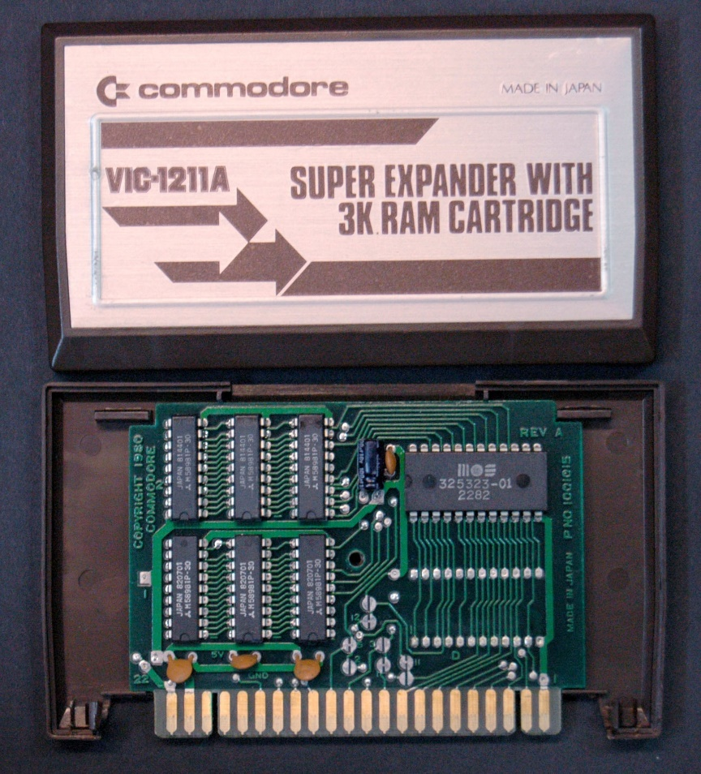

Figure : The Commodore VIC-1211A Super Expander Cartridge

With less RAM (1k) and another software, the same PCB is used as a (Commodore) diagnostic cartridge for the VIC-20.

The disadvantage for own projects is the usage of 2364/2332 ROMs. Thus, the Super Expander II is a version of the original Super Expander cartridge that can fit up to two 27C512 EPROMs. The configuration is done with jumpers, which also work as solder bridges (no pin header required), in case the configuration is not desired to be changed.

Two of the chip-select signals apply to each EPROM. The 8k memory bank can be selected with three jumpers. The selection applies to both EPROMs.

The 2114 4x1k (static) RAMs are the same, like in the original Super Expander. They are still available from some retro computer stores for a comparatively good price and also from AliExpress (search term “upd2114”).

# Configuration

## Chip selects

|  |  |  |  |
| --- | --- | --- | --- |
| **EPROM** | **Jumper** | **Chip Select** | **VIC-20 Address** |
| IC1 | JP1 |  | $4000 - $5FFF |
|  | $A000 - $BFFF |
| IC2 | JP2 |  | $2000 - $3FFF |
|  | $6000 - $7FFF |

Table 1: Configurable Chip Selects

## RAM Address

|  |  |  |
| --- | --- | --- |
| **RAM** | **Chip Select** | **VIC-20 Address** |
| IC3 (bit 0-3)  IC4 (bit 4-7) |  | $0400 - $07FF |
| IC5 (bit 0-3)  IC6 (bit 4-7) |  | $0800 - $0BFF |
| IC7 (bit 0-3)  IC8 (bit 4-7) |  | $0C00 - $0FFF |

Table 2: Mapping of the RAM ICs

## Memory Bank Select

There are two different types of addresses mentioned in this document:

* VIC-20 Address
* EPROM Offset Address

Both types must not be confused! The **EPROM Offset Address** is the address of the selected memory bank within (the program buffer of the EPROM). This is, where you load the different binary files to the EPROM buffer. One of those memory banks is selected with the Jumper JP3. This appears in/is mapped to the **VIC-20** memory at the **address** determined by the chip select (see Table 1).

|  |  |  |  |  |  |  |
| --- | --- | --- | --- | --- | --- | --- |
| JP3 | | | Address Bits | | | EPROM Address  (Offset) |
| **A15** | **A14** | **A35** | **A15** | **A14** | **A13** |
| SET | SET | SET | L | L | L | 0x0000 – 0x1FFF |
| SET | SET | OPEN | L | L | H | 0x2000 – 0x3FFF |
| SET | OPEN | SET | L | H | L | 0x4000 – 0x5FFF |
| SET | OPEN | OPEN | L | H | H | 0x6000 – 0x7FFF |
| OPEN | SET | SET | H | L | L | 0x8000 – 0x9FFF |
| OPEN | SET | OPEN | H | L | H | 0xA000 – 0xBFFF |
| OPEN | OPEN | SET | H | H | L | 0xC000 – 0xDFFF |
| OPEN | OPEN | OPEN | H | H | H | 0xE000 – 0xFFFF |

Table 3: 8k cartridges memory banks

# EPROMs

Four different types/sizes of EPROMs can be used with the Super Expander II, not all settings make sense with them. Their pin out is shown in Table 4.

The effect of the settings and the recommended configurations are shown in Table 5.

|  |  |  |  |  |  |  |  |  |  |  |  |
| --- | --- | --- | --- | --- | --- | --- | --- | --- | --- | --- | --- |
| 27C64 | | | | | | | | | | | |
|  | 27C128 | | | | | | | | | |  |
|  | 27C256 | | | | | | | |  |
|  | 27C512 | | | | | |  |
|  | SOCKET | | | |  |
| Vpp | Vpp | Vpp | A15 | 1 | A15 | VCC | 28 | VCC | VCC | VCC | VCC |
| A12 | A12 | A12 | A12 | 2 | A12 | A14 | 27 | A14 | A14 | /PGM | /PGM |
| A7 | A7 | A7 | A7 | 3 | A7 | A13 | 26 | A13 | A13 | A13 | n.c. |
| A6 | A6 | A6 | A6 | 4 | A6 | A8 | 25 | A8 | A8 | A8 | A8 |
| A5 | A5 | A5 | A5 | 5 | A5 | A9 | 24 | A9 | A9 | A9 | A9 |
| A4 | A4 | A4 | A4 | 6 | A4 | A11 | 23 | A11 | A11 | A11 | A11 |
| A3 | A3 | A3 | A3 | 7 | A3 | /OE | 22 | /G/Vpp | /G | /G | /G |
| A2 | A2 | A2 | A2 | 8 | A2 | A10 | 21 | A10 | A10 | A10 | A10 |
| A1 | A1 | A1 | A1 | 9 | A1 | GND | 20 | /E | /E | /E | /E |
| A0 | A0 | A0 | A0 | 10 | A0 | D7 | 19 | D7 | D7 | D7 | D7 |
| D0 | D0 | D0 | D0 | 11 | D0 | D6 | 18 | D6 | D6 | D6 | D6 |
| D1 | D1 | D1 | D1 | 12 | D1 | D5 | 17 | D5 | D5 | D5 | D5 |
| D2 | D2 | D2 | D2 | 13 | D2 | D4 | 16 | D4 | D4 | D4 | D4 |
| GND | GND | GND | GND | 14 | GND | D3 | 15 | D3 | D3 | D3 | D3 |

Table 4: EPROM pin compatibility

|  |  |  |  |  |
| --- | --- | --- | --- | --- |
| EPROM | Size | A15 | A14 | A13 |
| 27C512 | 64kx8 | yes | yes | yes |
| 27C256 | 32kx8 | HIGH | yes | yes |
| 27C128 | 16kx8 | HIGH | HIGH | yes |
| 27C64 | 8kx8 | HIGH | HIGH | HIGH |

Table 5: Settings per EPROM type

In case Vpp is located at a dedicated pin (pin 1), A15 has no effect anymore. A HIGH level is recommended (switch is off). The /PGM Pin should be set HIGH. The n.c. (not connected) pin should be HIGH (with pull-up resistor) or open.

# Using parallel EEPROMs

There are ***parallel*** EPROMs, which fit into the EPROM sockets. They do not require erasing with a UV eraser, like EPROMs, but the price is higher.

Since they can be written, which is controlled by the signal, but the Super Expander II cartridge is lacking of this functionality, this signal has to be HIGH (inactive). The 28C256 has the A14 signal connected to Pin 1, which is A15 of the EEPROM socket. This is no problem, but it has to be kept in mind, that the jumper for A15 has effect on the bank select A14 of the EPROM.

|  |  |  |  |  |  |  |  |
| --- | --- | --- | --- | --- | --- | --- | --- |
| 28C64 | | | | | | | |
|  | 28C256 | | | | | |  |
|  | SOCKET | | | |  |
| n.c. | 💣A14 | 1 | A15 | VCC | 28 | VCC | VCC |
| A12 | A12 | 2 | A12 | A14 | 27 | /WE | /WE |
| A7 | A7 | 3 | A7 | A13 | 26 | A13 | n.c |
| A6 | A6 | 4 | A6 | A8 | 25 | A8 | A8 |
| A5 | A5 | 5 | A5 | A9 | 24 | A9 | A9 |
| A4 | A4 | 6 | A4 | A11 | 23 | A11 | A11 |
| A3 | A3 | 7 | A3 | /OE | 22 | /G/Vpp | /OE |
| A2 | A2 | 8 | A2 | A10 | 21 | A10 | A10 |
| A1 | A1 | 9 | A1 | GND | 20 | /E | /CE |
| A0 | A0 | 10 | A0 | D7 | 19 | D7 | D7 |
| D0 | D0 | 11 | D0 | D6 | 18 | D6 | D6 |
| D1 | D1 | 12 | D1 | D5 | 17 | D5 | D5 |
| D2 | D2 | 13 | D2 | D4 | 16 | D4 | D4 |
| GND | GND | 14 | GND | D3 | 15 | D3 | D3 |

Table 6: EEPROM pin compatibility

|  |  |  |  |  |
| --- | --- | --- | --- | --- |
| EEPROM | Size | A15 | A14 | A13 |
| 28C256 | 32kx8 | =A14 | OPEN | yes |
| 28C64 | 8kx8 | OPEN | OPEN | OPEN |

Table 7: Settings per EEPROM type

# Dimensions

The dimensions of the Super Expander II are identical to those of the original super Expander PCB.

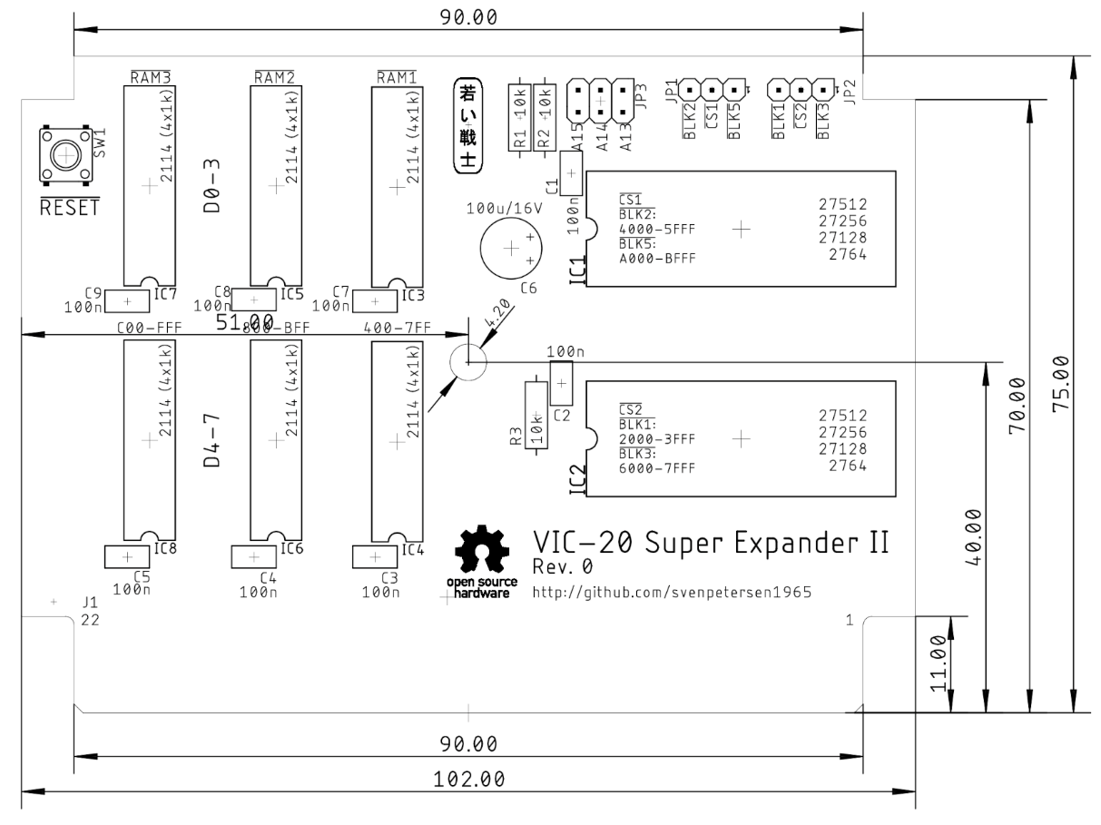

Figure 2: Dimensions of the Super Expander II

The PCB fits the original super Expander cartridge case, another VIC-20 cartridge case from Commodore or the [tfw8bit.com](http://www.tfw8bit.com) cartridge case.

The VIC-20 cartridge cases are high enough to fits the Super Expander II PCB even with the ICs on sockets and vertical jumpers. This has been verified for the Super Expander case and the tfw8bit case. The tfw8bit case and the “other Commodore VIC-20” cases require two T-shaped board supports in the middle of the lower shell to be removed.

# Revision History

## Rev. 0

* Prototype: Fully functional.